NAME:Rishik JK
REG.NO :192511052

CSA1702-ARTIFICIAL INTELLIGENCE
LAB EXPERIMENT

25. Prolog Program to Implement Monkey Banana Problem

1. Aim
To write a Prolog program to solve the Monkey Banana problem using logical reasoning and state transitions.

2. Algorithm
- Start the program.
- Define the initial state of the monkey, box and banana.
- Check whether the monkey can reach the box.
- Move the box below the banana.
- Allow the monkey to climb the box.
- Check whether the monkey can grab the banana.
- Display the result.
- Stop.
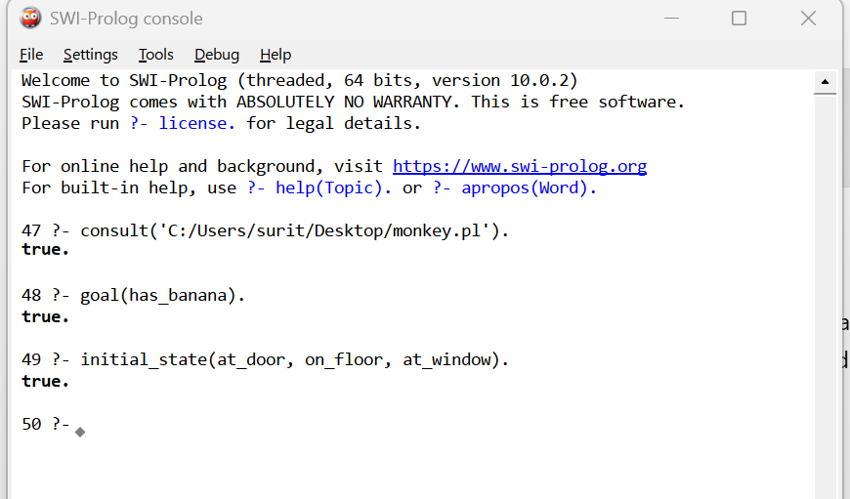

6. Result
Thus, the Prolog program to represent the Monkey Banana problem was successfully implemented and executed. The monkey reaches the banana and obtains it through the defined actions.

